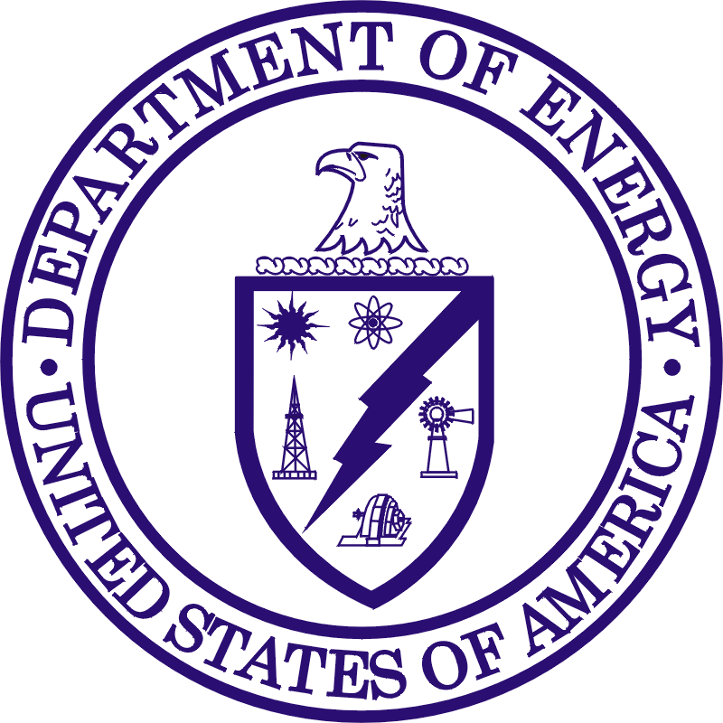
Department of Energy
Office of Science
Washington, DC 20585

Office of Science

DATE

MEMORANDUM FOR (NAME GTN OR FORS), FACILITY SECURITY MANAGER
OFFICE OF PHYSICAL PROTECTION
OFFICE OF HEADQUARTERS SECURITY OPERATIONS

FROM: NAME OF HOST
POSITION OF HOST
NAME OF ELEMENT

SUBJECT: Visitor Access to Forrestal/Germantown Building

The purpose of this letter is to formally request that on (day, date), the U.S. Citizen(s) below is/are scheduled to access the DOE Forrestal/ Germantown Building for (purpose / need for being in building). The meeting is scheduled to begin at (time only), and will be held in (room # and location). The following individual(s) are scheduled to attend:

List names

(Name of POC) will act as the point-of-contact and is available on (contact number).

cc:
T. Earl
G. Sloan
D. Dorsey
N. Day

