**Office of Science  
  
Oversight Model Basic Primer**

The Department of Energy (DOE) is both the owner and regulator of the DOE sites.  Therefore, DOE is ultimately responsible for ensuring that all DOE activities, regardless of whether they are performed by DOE federal employees or by DOE contractors, are performed safely (i.e. protective of the worker, the public, and the environment) and efficiently while achieving mission objectives (i.e. work results of a quality level commensurate with their importance to the mission).   
  
DOE performs oversight to confirm the outputs of the contractor’s Quality Assurance programs and Contractor Assurance System (CAS).  Oversight includes formal processes such as assessments, audits, reviews, inspections, tests, surveillances, and investigations, as well as less formal processes such as facility tours, walk-throughs, work observations, document and record reviews, attendance of contractor meetings, and other routine interactions with contractor management and staff.   The oversight expectations, and mix of formal and informal oversight activities performed, are established through risk-informed determinations.

We (DOE) integrate our activities with the CAS, and our activities include:

* review of contractor management system documents and records;
* review and analyses of the outputs  of the CAS, including peer reviews and internal contractor assessments of operations, facilities, projects, programs, and systems;
* performance of operational awareness activities such as assessments, surveillance, inspections, work observations, surveys, walkthroughs, and attendance of contractor meetings.
* review of CAS management system information and trends and direct activity observation (boots on the ground) etc.

When we do oversight activities the contractor is afforded the opportunity to explain to the SC line management oversight personnel how their systems work in the functions being examined.  SC line management communicates oversight results to the contractor who in turn determines what actions to take in response to the oversight results, then tracks those actions through completion and verification of effectiveness.  SC line management uses risk-based considerations to select corrective actions for follow-up validation.

SC line management integrates the information generated by the above processes to evaluate the adequacy and effectiveness of CAS and other contractor management systems. SC line management oversight of Management and Operating contractors’

operations is primarily conducted by the SC Site Office Staff with support, as needed, from the SC Integrated Support Center. This is an efficient use of resources, as all SC Field Offices report directly to SC-3.

A well-functioning CAS is when there is a good working relationship between the Laboratory and the Corporate Parent with full coordination and cooperation of both which will eliminate confusion and maximize execution of the SC mission. See following flow diagram.

Contractor Assurance System is a contractor-designed and utilized system to manage performance consistent with contract requirements. In July of 2009, The SC Deputy for Field Operations chartered a federal/contractor team to improve the execution of Contractor Assurance at Science National Laboratories. The team developed a new H clause that would be modified into all of the SC Laboratories’ contracts by January 2010.    
  
CAS is a critical element of how SC manages the National Laboratories, and is therefore an important component of SCMS.  It has been incorporated into each pertinent Management System to show the complete interaction between Federal and Contractor responsibilities in all functional areas.  This framework engages the corporate parent to assess performance, to provide data to the contractor’s management decision-making process, and to allow the contractor to more effectively manage processes, resources and outcomes. The system provides transparency between the contractor and DOE to ensure alignment across the complex to accomplish mission needs, and for DOE to determine the necessary level of Federal oversight.

From June through August 2013, SCMS was evaluated to see how CAS could be appropriately added.  In September 2013, the overall process began to incorporate CAS into SCMS as fully and completely as possible.

The goal for incorporating CAS into all SCMS Management Systems is to accomplish improved relationships with the SC contractors, to streamline decisions for closer work, to focus on performance not compliance, and to provide a succinct way to convey necessary requirements in all areas.  This new aspect enhances SCMS by bringing together in one set of procedures and processes the requirements-based interaction between Federal and Contractor Office of Science employees at Headquarters, the ISC, the Site Offices, and the SC National Laboratories.

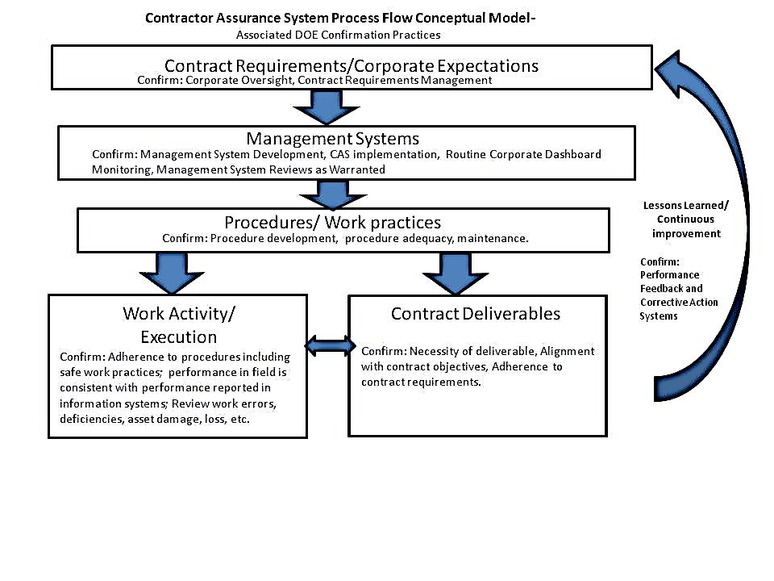

**DOE Site Office - Confirmation Activity/ Skills Matrix**

|  |  |  |
| --- | --- | --- |
| **Performance Evaluation Source** | **DOE Activity** | **Functional Skill Need** |
| Contract Requirements/  Corporate Expectations | Review of requirements management system and periodic review of content changes for:   * Translation error/omission/additions * Intent change | * Systems/program analyst/Technical Editor to evaluate contract for errors/omissions, etc. * Contracting Officers to determine appropriate contract language * Technical SMEs to determine appropriate contract language |
| Management System/ CAS performance data | * Routine review of management system data outputs/metrics * Review of systems as needed | * System/program/management analysts to analyze data for trends, issues * Technical SMEs to determine importance of analyses * Technical SMEs to review individual systems |
| Procedures/ Work practices | * Review body of procedures for completeness * Review adequacy of procedures for internal consistency and accuracy | * Quality control for review * Technical SMEs for review of adequacy of procedures |
| Work Activity/ Execution | * Review of work activity delivery information systems * Periodic observations of work activities (risk based) * Review Work Errors (personnel injuries/work product deficiencies/asset damage/loss) | * General broad technical (facility representatives and others) * Technical SMEs for specific activities |
| Contract Deliverables | * Review of Contract Deliverables (does it meet intent) | * Contracting officers to determine compliance with contract * Technical/Administrative SMEs |
| Lessons Learned/Continuous Improvement Systems | * Review of performance feedback and corrective action systems | * System/program/management analysts |