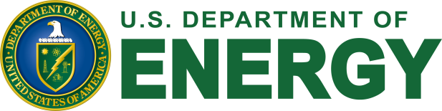

5th Workshop on Isotope Federal Supply and Demand
Wednesday, November 9, 2016
Hyatt Regency Bethesda, Maryland

REGISTRATION FORM

Please return by October 26, 2016
Fax: 301-903-3833
E-mail to: SC.IsotopeWorkshop@science.doe.gov

NAME: ……………………………………………………………………………………

Organization: ………………………………………………………………………

ADDRESS: ………………………………………………………………………………

TEL: ……………………………………. FAX: ………………………………….

E-MAIL: …………………………………………………………………………………

SPECIAL NEEDS: ……………………………….……………………....……………

Will you be attending the Workshop on November 9, 2016?

◻ Yes
◻ No
◻ No, but I would like to receive further information about the workshop or future events.
◻ Yes, and I would be interested in making a brief presentation at the workshop about my Agency’s demand and/or supply of isotopes; or about a concern my Agency has on the supply/demand of an isotope.

Workshop Web Site: Workshop on Isotope Federal Supply and Demand

